Plans Beyond PCG
Yes. We discussed quite a few things for your tank game beyond PCG. Your direction has evolved from a story-based tank game into a Brotato-inspired, wave-based survival game, with tank-specific combat and a focus on completing one polished level first.
Here's the consolidated list of what we've discussed, including existing systems and future plans.

1. Core gameplay systems
Tank movement and aiming
Your TankMovement and AimTurret systems, including Rigidbody2D-based movement and turret rotation.
Implemented
Weapons and damage
Your WeaponTurret setup, bullet pooling, collision handling, and damage system.
Working
Health and UI
Tank health with a maximum of 100, a health slider, and working damage/blast visuals. You also wanted to polish the health bar and UI presentation.
Core functionality working
Enemy AI
Enemy detection, shooting range, and static AI behavior. We discussed an issue where enemies moved toward the world origin because of the parent/child hierarchy and Rigidbody2D positioning.
Needs polish
Wave and spawning systems
Your WaveManager, SpawnManager, and EnemySpawner, including unique spawn-point selection, wave timing, and enemy prefab management.
Integration and balancing
2. Features planned beyond PCG
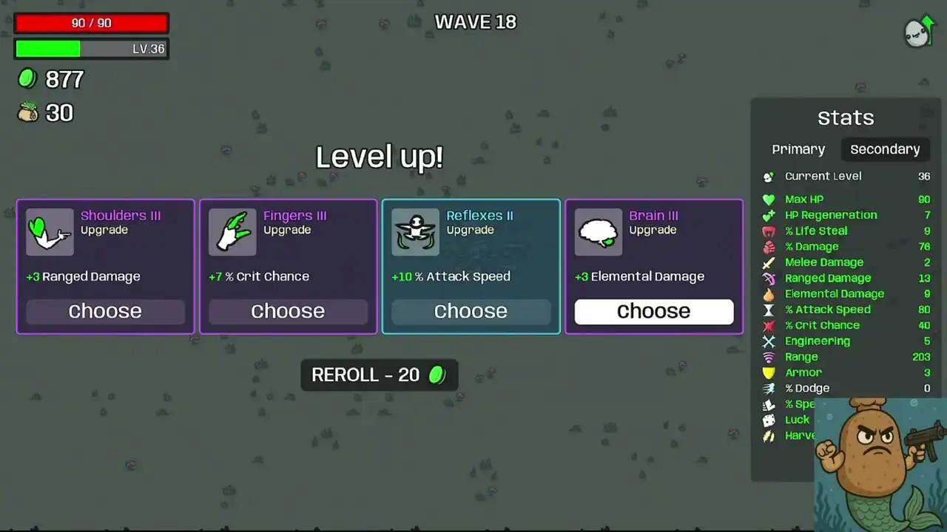
Add to Favorites
Progression and upgrades
We discussed adding a progression system inspired by Brotato. This could include upgrades between waves, improvements to tank statistics, and choices that shape a run.
This is a planned system, not something we've established as implemented.
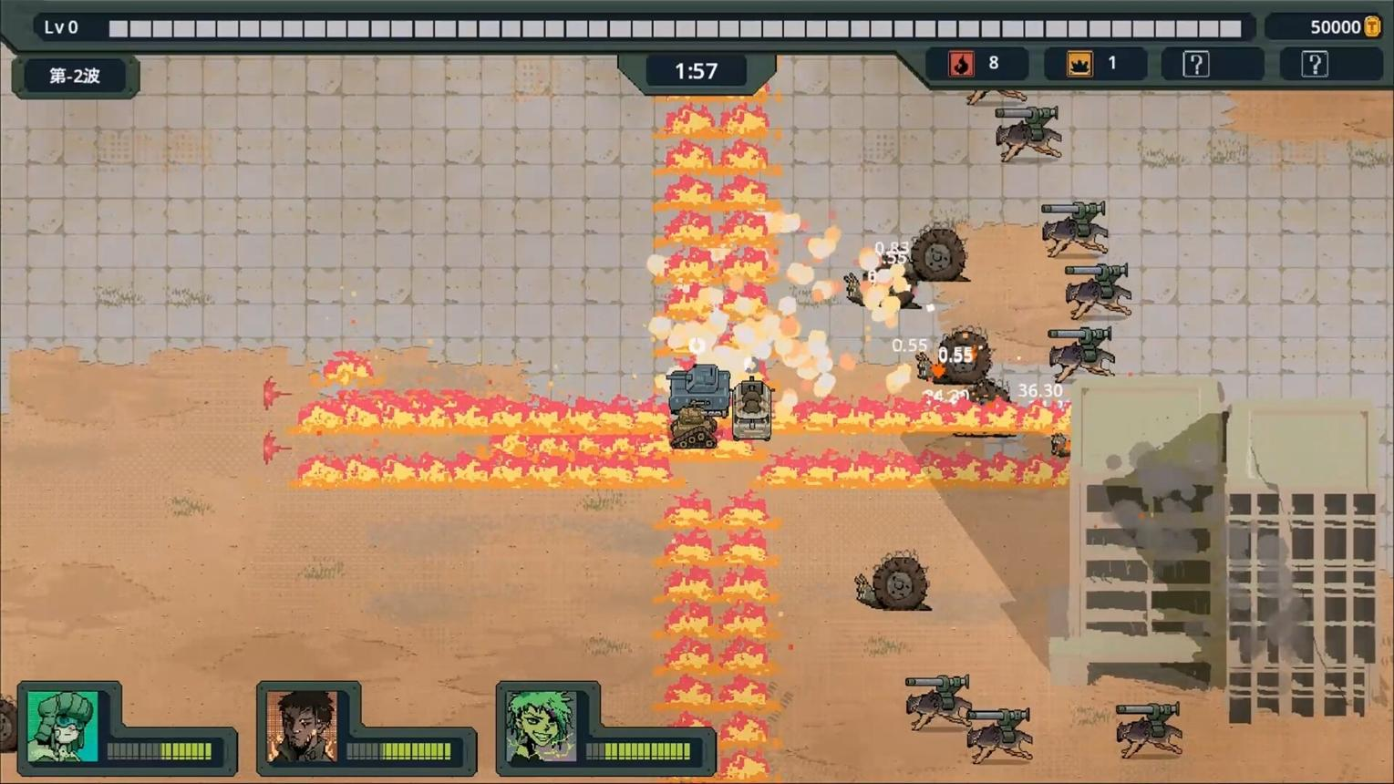
Add to Favorites

Add to Favorites
A proper wave gameplay loop
We discussed progressing from a basic wave to multiple waves, increasing difficulty, and handling level completion. The game needs a clear gameplay cycle rather than simply spawning enemies indefinitely.
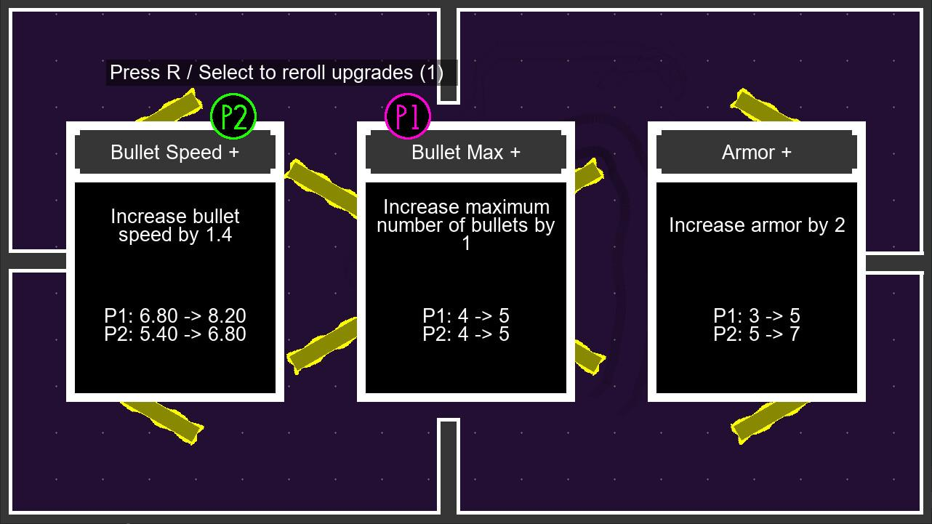
Add to Favorites
UI system and game flow
You planned a more complete UI system alongside PCG and progression, including the presentation needed for wave status, health, and eventually upgrade selection and run completion.
3. Technical work and polish we discussed
- Boundary behavior: Your tank's movement boundaries were working, with limits around x=±13.5x = \pm 13.5x=±13.5. You had also mentioned revisiting the speed-reset behavior near boundaries.
- Enemy spawning: Spawn points should be selected without repeatedly choosing the same point within a spawning cycle.
- AI and prefab hierarchy: Your enemy prefab uses an Enemy parent with AI scripts and a child tank containing the reusable tank controller, damage, Rigidbody2D, and movement components.
- Presentation: You wanted more polished health-bar feedback and visual effects, not merely functional UI.
- Architecture: You were considering the separation between presentation and gameplay assemblies, while keeping the current prototype focused on C# implementation rather than prematurely building an elaborate architecture.
4. The development order we had in mind
This is the order that best matches the plans you've already established.
- Finish the first playable level
Stabilize tank combat, enemy AI, wave flow, health, and UI.
- Integrate PCG into the main scene
Your generator is nearly complete in its separate test scene. Preserve that working version and integrate it incrementally.
- Connect PCG to gameplay
Validate the generated battlefield, then make enemy spawning use valid positions from the generated map.
- Build the progression system
Introduce wave scaling and upgrade choices after the core loop works.
- Implement character switching
Establish how different tanks or characters affect gameplay, then connect those choices to progression if appropriate.
- Polish and test the complete level
Check that map generation, combat, UI, enemy spawning, and progression work together.
One other detail: we discussed using Rootbin's Brotato recreation as a reference for wave and enemy-spawner architecture. The intention was to learn from its structure, not to clone Brotato's entire game.
The main objective remains one complete, replayable level. PCG is one part of that goal, alongside progression, character switching, wave combat, and UI. Finishing those systems in a working order is more valuable than adding another five features before the existing ones cooperate.

